

College of Engineering
Department of Mechanical Engineering
Fall Semester 2017-2018

Senior Design Project Report
Under-water Energy Storage System
In partial fulfillment of the requirements for the Degree of Bachelor of Science in Mechanical Engineering Team Members
Team Members
Student Name | Student ID
Hassan Al Yousef | 201400125
Ali Al Ameer | 201400125
Abdualaziz Al Qarny | 201200569
Mohammad Al Gamdy | 201302287
Mohammad Al Subaie
Khaled Bo Ali

Advisor: Dr. Panos Sphicas

Abstract
Energy storage is the capture of electricity produced at one time for use at a later time. With increasing fuel prices, energy storage becomes more popular and financially practical. Some technologies provide short-term energy storage, while others can endure for much longer. Common examples of energy storage are batteries, hydroelectric dams, thermal storage tanks, and flywheels. Bulk energy storage is currently dominated by hydroelectric dams, both conventional as well as pumped. Underwater compressed air storage (UCAS) provides a promising low-cost alternative to bulk energy storage. Anchoring structures in the seabed imposes a technical challenge and an increased cost for any UCAS system. Additionally, the material of the UCAS is an area needing more development. For this project, we tested different types of anchors and designed. Also, we built and tested a prototype of UCAS in a swimming pool. The results seems promising and can be a good base for further researching and testing

Chapter 1: Introduction

1.1. Background and Motivation

When the Industrial Revolution took place between the 18th and 19th centuries, fossil fuels became the main energy source and their consumption has increased dramatically. According to the Annual Energy Review 2011 by the U.S. Energy Administration, the fossil fuel segment of total energy consumption in the U.S. is 82 % (EIA, 2011). Even though fossil fuels are gladly available at present, there is not an infinite source of fossil fuels, so finally they will be depleted. Moreover, since there are environmental issues associated with burning fossil fuels, efforts to reduce the dependency on fossil fuels are increasingly gaining momentum worldwide. Demand for renewable energy generation has been elevated significantly in latest years, these renewable energy sources, however, have a critical disadvantage, namely impulsiveness of supply. For example, weather and climate can often affect renewable energy sources such as wind, solar, tidal, and wave, or these renewables would likely be strong at off peak times. Bearing in mind nuclear power generation a base load supply, the energy from renewables must be dispatch able to compete and replace conventional fossil fuels

In order to provide high quality power from renewable energy sources to the grid, a bulk energy storage system will be required as a buffer. Several energy storage methods are being developed with different performances in terms of power ratings and discharge times. Figure 1.1 shows the comparison of the power rating and the discharge time for several energy storage systems. Pumped hydro energy storage (PHS), flywheel energy storage (FES) and battery storage are the most common kinds of energy storage systems now in use or in development. Battery storage systems and FES are quick-responding and efficient, but they are expensive and small-scale so that they commonly work as a power quality system and an emergency power backup system. PHS is large-scale, but the building is costly and subject to geographic limitations.
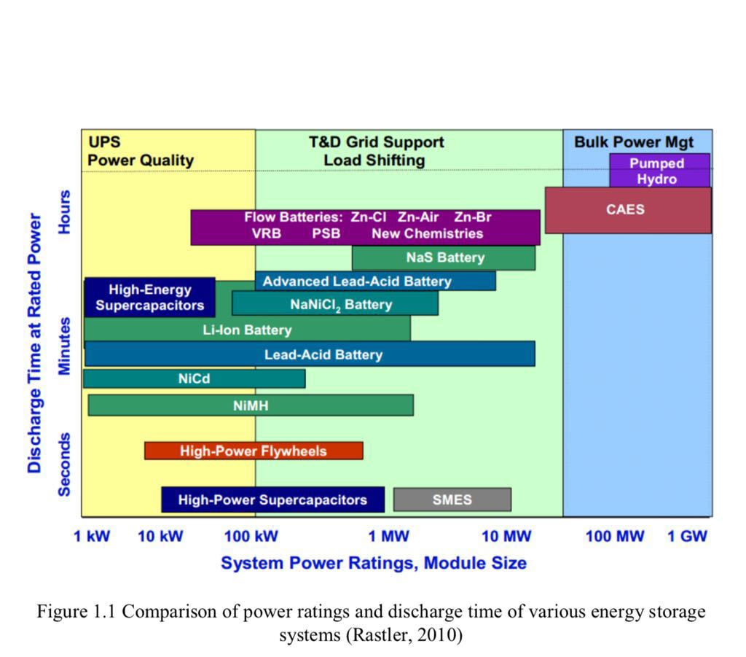

As a near-term utility-scale energy storage technology, compressed air energy storage (CAES) is worth studying because CAES is a scalable, economical, and proven technology. In North Carolina, efforts to utilize the potential of offshore energy have begun and ocean compressed air energy storage (OCAES) systems are being examined as an energy storage option (note: OCAES is sometimes referred to as “Offshore Compressed Air Energy Storage”). Installation of an air storage container on the seabed not only avoids the environmental and safety issues of an inland facility, but also takes advantage of the hydrostatic pressure at the ocean floor which can keep the compressed air under storage at high pressure without the need for an expensive pressure vessel or underground cavern.

Objectives

-Design different anchoring methods and test them
-Test a variety of materials that can be used for the UCAS
-Test a prototype UCAS.

Chapter 2: Literature Review

2.1 Project background

The idea is to create an energy storage solution that can store energy during the times where the demand of electricity is low and the production is high. This can be done by a pressurized underwater balloon system that can store renewable energy or any other type of energy. This solution is considered to be the lowest cost energy storage solution available.
The system uses electricity to compress air in the times that we have extra electricity. The air is then pumped through a pipe into large balloons placed in the bottom of the sea, 60 meters of depth would be fine for such a project. The weight of water will keep the balloons pressurized.

In order to generate the electricity back, the pressurized air returns to the surface. A generator will receive the air from the balloons which were placed in the bottom of the sea. The idea is that electricity can be stored at off-peak times when power is more than what we need, then recovered when demand of power is high, or when any of the main power generators fail.

Traditional energy sources, like gas and diesel, are often needed at peak energy times or to supplement renewable power sources, such as wind and solar when they do not generate energy, for instance, at night or when there is no wind.

However, this new solution could reduce the use of traditional energy sources like oil and gas and as a result saving the environment. Also, it could reduce the costs of providing electricity to the customer.

Extra Advantages of the system:
1) Could be highly efficient
2) Require small amount of land space
3) Matches the goals of “vision 2030” launched by Prince Mohammad bin Salman.
Note: similar system is only installed in Canada-Toronto city.

2.2 Previous Work

The two conventional CAES systems, in Huntorf, Germany and in McIntosh, AL, are
currently in operation. These two facilities have been successfully served main functions of
energy storage for over 35 years and 22 years, yielding actual long-term operational data.
Figure 2.2 shows the aerial views of the Huntorf plant and the McIntosh plant. Table 2.1
presents the specifications of the existing CAES systems (Basler & Zaugg, 1985; Crotogino,
Mohmeyer, & Scharf, 2001; Desai, Gonzalez, Pemberton, & Rathjen, 2005; E.ON, 2013; A.
J. Pimm, 2011; Pollak, 1994a; Schainker, Pollak, & Mehta, 1993; Singal, 1984; Steta, 2010;
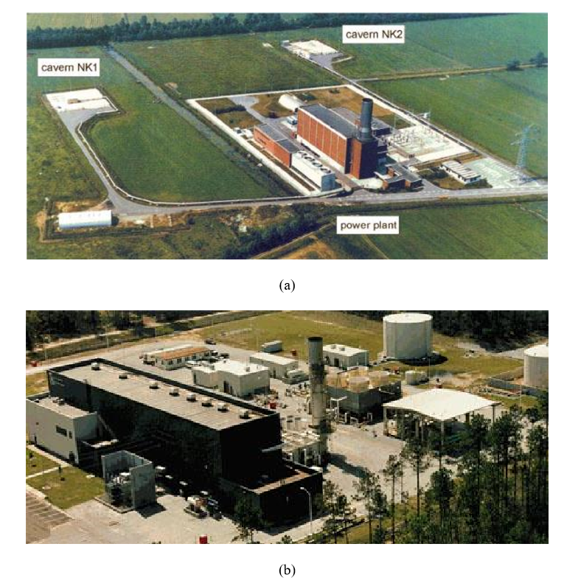
Tuschy, 2002).
Figure 2.2 Aerial views of (a) the Huntorf CAES plant and (b) the McIntosh CAES plant (Abele, 2011)

The world’s first CAES plant located near Huntorf, Northern Germany has operated since
1978 with a rated power of 321MW (upgraded from 290MW in 2007) (E.ON, 2013). The
Huntorf CAES plant which can generate electricity less than 3 hours was mainly built for
spinning reserve for a regional nuclear plant. It is currently serving to level the variable wind
turbine power (Crotogino et al., 2001; Steta, 2010; Succar, 2008). Two salt caverns with a
Table 2.1: Comparison of the existing CAES plants
Parameter Huntorf (Germany) McIntosh AL (USA) Build Year 1978 (rebuilt in 2007) 1991 Power Capacity Turbine 321 MW 110 MW (2 hours) (26 hours) Compressor 62 MW 53 MW (12 hours) (41 hours) Cavern Volume 310,000 m3 560,000 m3 Mass Flow Rate Turbine 455 kg/s 157 kg/s Compressor 108 kg/s 94 kg/s Cavern Air Pressures Discharged (Min) 4.2 MPa 4.6 MPa Charged (Max) 7.2 MPa 7.4 MPa High Pressure Turbine Air Pressure 4.13 MPa 4.4 MPa Air Temperature 490 Cº 540 Cº Low Pressure Turbine Air Pressure 1.28 MPa 1.6 MPa Air Temperature 945 Cº 870 Cº Fuel Gas Gas/Oil Recuperator No Yes Heat Rate 5,800 kJ/kWh 4,300 kJ/kWh Roundtrip Efficiency 42% 54%

total volume of 310,000m3 store compressed air at the pressure between 4.2 MPa and 7.2
MPa. The second CAES was built in McIntosh, Alabama. The McIntosh plant provides a
long-term generation period of up to 26 hours due to the help of a larger cavern volume of
560,000m3. This plant stores excess electric energy from Power South coal-fired plant and
retrieves it during on-peak, high-priced times (Dresser-Rand, 2010).
Figure 2.3 illustrates the schematic diagram of the McIntosh CAES plant. The fundamental
schematics for the CAES plants in Huntorf, Germany and McIntosh, AL are identical except
for the recuperator, in which the waste heat of the exhausted air from a low pressure
expander is recycled to increase the compressed air temperature before it goes into a high
pressure combustion chamber. By making use of the recuperator, the fuel consumption of the
McIntosh CAES plant was decreased by 25% relative to the Huntorf CAES plant (A. J.
Pimm, 2011).

Chapter 3

This chapter will be split into 3 parts. The first part will cover the anchoring. The second is the balloon material and the third our prototype. But before, the Design constrains and methodology are described for all three parts

3.1 Design Constraints and Design Methodology

The UCAS can be used in places all around the world as along as the 60 m depth of water exist. The constraints that can affect the overall design of the UCAS are as follows:
- Environments
- Economical
- Manufacturability
- Safety
- Sustainability
- Geometrical constraints
- Engineering standards
The design constraints above will be taken into consideration in more details. The final design of the UCAS will have to take in consideration of the effect that any changes in dimensions will have as a result. The project will apply the engineering standards for future manufacturing to allocate the parts used in UCAS.

Environments
There are limitations on where underwater CAES systems can be installed. According to the Pimm & Garvey report linked to earlier the ideal depth for such systems is 500-700m, and the system should be located within 5km of the coast to minimize losses in the air pipe that connects the spheres with land-based facilities. This raises the question of resource availability, which according to Pimm & Garvey’s study is abundant around Europe and North America, and which according to Greentechmedia amounts to 817 TWh worldwide. There are, however, questions as to how globally abundant inshore CAES resources really are.

Economical
The main benefit of using the UCAES is to save the energy which means saving money ate the same time. Building the project is cost but it is worth it at the end

Manufacturability
The system can’t be manufactured very easily. The main constraint that we face during the manufacturing of the project is the assembly of the system in the sea. We need technical diving team for such a project.

Safety
The environment that we are dealing with in installing the project is the bottom of the sea. So we need to be careful about the sharks in the area. All team members must be familiar with the diving safety considerations and requirement regarding the use of the diving equipment and techniques

Equipments:
# | Item | Buy / Rent |  | Quantity | Price | Picture
1 | Anemometer |  |  | 1 |  | 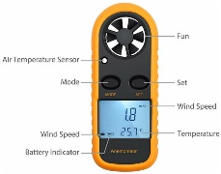
2 | Industrial Crane Scale |  |  | 1 |  | 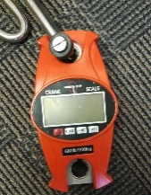
3 | Pressure regulator |  |  | 1 |  | 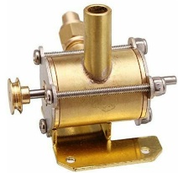
4 | Experimental Turbine |  |  | 1 |  | 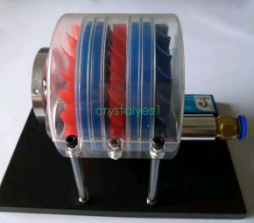
5 | Dynamo Generator |  |  | 1 |  | 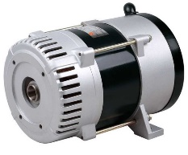
6 | Balloon |  |  | 1 |  | 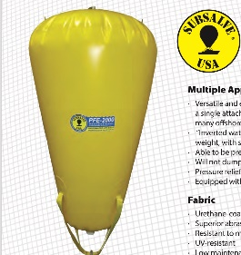
7 | Polly
8 | shackles |  |  | 2 |  | 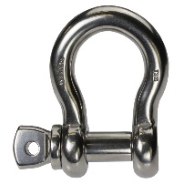
9 | Tubes
10 | Robs |  |  |  |  | 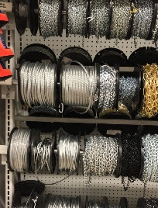
11 | Iron beams
12 | Compressor |  |  | 1
13 | Valves
14 | Pressure gage
15 | Voltmeter |  |  |  |  | 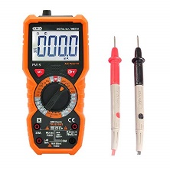

3.1 The anchoring system

Compressed air energy storage is known to have strong potential to deliver high-performance energy storage at large scales for relatively low costs compared with any other solution. Underwater Storage Energy is a project where the anchoring system has the main important part because in this section it will identify the system usage, the method to install then the calculations with the outcomes. Underwater storage of pressurized air is characterized by three important attributes: (1) it has the potential to achieve very low cost per unit of energy stored, (2) it naturally tends to exhibit an isobaric (constant pressure) characteristic of pressure versus fill-level, and (3) in stark contrast to underground air storage, it is feasible in many locations to establish economically competitive compressed air stores at relatively small scales—measured in tens of megawatt-hours rather than gigawatt-hours. As a matter of fact, we searched for different types of anchoring where force and cost are our target. Actually, in this part we would like to test how can we reach maximum Force with lower cost as shown (Figure 1).

As listed up in the figure we listed the five different types of anchoring system:
- Bricks.
- Helix Beam.
- Normal Pipe.
- Sharp Edge Beam.
- Rocks Bag.
And through this part we will evaluate and discuss each and every element individually. Then we test results and finally we decide which type is better.
- Bricks
A concrete block is primarily used as a building material in the construction of walls. It is sometimes called a concrete masonry unit (CMU). A concrete block is one of several precast concrete products used in construction. The concrete commonly used to make concrete blocks is a mixture of powdered portland cement, water, sand, and gravel. This produces a light gray block with a fine surface texture and a high compressive strength. A typical concrete block weighs 38-43 lb (17.2-19.5 kg). In general, the concrete mixture used for blocks has a higher percentage of sand and a lower percentage of gravel and water than the concrete mixtures used for general construction purposes. This produces a very dry, stiff mixture that holds its shape when it is removed from the block mold.
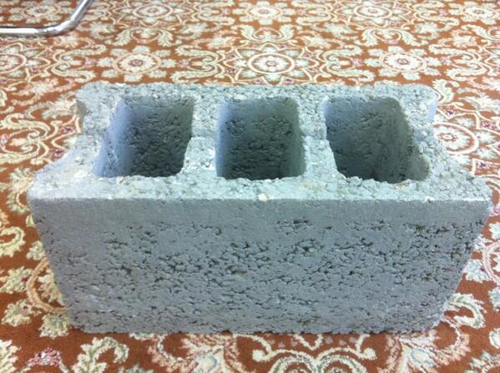

Helix Beam | Normal Pipe | Sharp Edge Beam | Rocks Bag
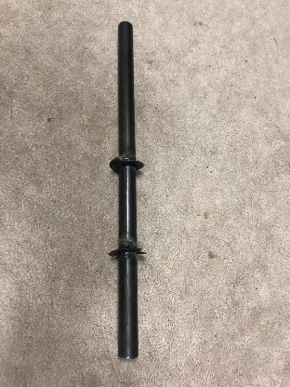 | 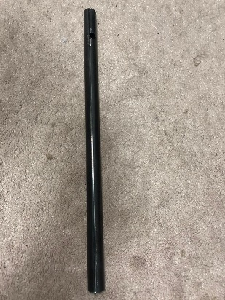 | 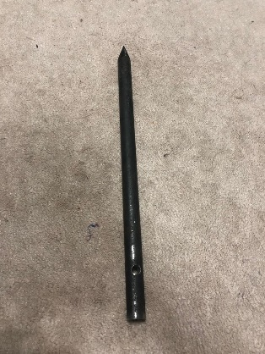 | 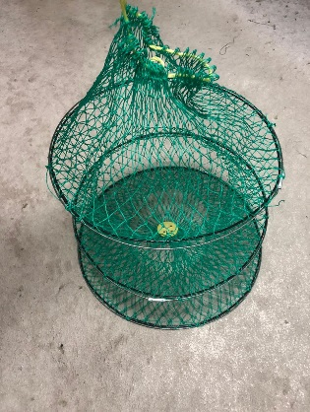

Under water energy bag material review.

The underwater energy storage system requires a type of vessel or energy bag that can change the shape and volume depending on the amount of air stored in it. For example, balloons in particular can be used as an energy bag because of their flexibility and the ability to remain close to the hydrostatic pressure of the surrounding water under the sea. There are two main advantages for these characteristics which are:
- The forces across the membrane will always be lower than if the structure gave any significant resistance to bending.
- No matter how much air is stored inside the bag, the pressure of the air moving from the bag in to the turbine, when retrieving the energy, will roughly be constant allowing the turbomachinery efficiency to be higher than the efficiency of a fixed volume storage.
Looking into how much important the flexibility and durability of the underwater storage balloons raises questions regarding the materials used for manufacturing energy storage bags. Both underwater inflatables and water load test weights share many similarities with Energy Bags, in that they are reinforced fabric structures designed to carry the same loads while separating water and air. Also, underwater inflatables designs consider the withstand of the marine environment.
There are a couple of existing companies that have experience in designing and manufacturing lift bags. Inflatable lifting bags are used for the lifting of wrecks, sunken ships and submarines, concrete pipes, and other items from the seabed to the surface, or for the short term support of an underwater item. They have become popular for these uses because they are cheap, reusable, lightweight, and require relatively little storage space.
Seaflex Ltd. are an Isle of Wight based manufacturer of marine air lift bags and water load test weights with over 15 years’ experience. In one of their more interesting projects, they supplied five of their open bottom 10t Series 063 air lift bags to Industrikonsult which were used at a depth of 293m to lift the corner of a subsea oil production template in the Vigdis oil field while seabed stabilization operations were undertaken [1]. The five bags, providing a total of 50t of lift, were attached to a single lifting point with a complex rigging arrangement. The bags conform to IMCA D 016, an international standard for underwater air lift bags [2], and HSE regulations, and are fitted with a bottom operated dump valve.
Seaflex air lift bags have RF (radio-frequency) welded seams, high tensile polyester 3×3 Panama base cloth with UV stabilized PVC coating on both sides, and a ¾” inflation valve. In accordance with IMCA D 016 they have a 5:1 safety factor [3].
JW Automarine Ltd. of Norfolk have been designing and manufacturing inflatable lifting bags since 1972. They make parachute type lifting bags with both open and closed bottoms, and with lifting capacities of up to 50t. Their PR35 35t closed bottom parachute lifting bags were used to raise a North Korean submarine. And as advertised on Seaflex and JW Automarine’s websites, closed bottom bags are used for lifting items to the surface, though IMCA D 016 clearly recommends that “only open bottom bags should be used where any form of ascent is planned or possible, such as vessel salvage or raising objects from the seabed. Fully enclosed bags should not be used for this purpose.” However, integrated pressure relief valves, with adequate flow rate, provide the necessary release of air as these bags rise to the surface.
JW Automarine’s bags are manufactured from “high tenacity” Trevira™ polyester cloth with PVC coating, and have RF welded seams “for strength and integrity”. The fabric has a temperature operating range of -40°C to 700°C [4]. Their larger lifting bags (3t and upwards) feature a load restraining harness of heavy duty polyester webbing which is fabricated into the skin of the bag, and their smaller bags have load restraints of heavy duty polyester webbing which are sewn and welded to the skin of the bag. All of their lifting bags have a minimum safe working load ratio of 6:1[5].
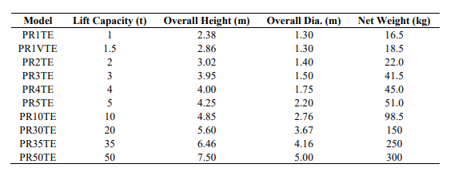
(Table 1) Technical specifications for JW Automarine’s range of totally enclosed parachute type inflatable lifting bags [5]

The technical specifications of JW Automarine’s range of totally enclosed parachute type lifting bags are given in table 2.4, and their relative sizes are shown in figure 1. These bags have a lanyard-operated large dump valve, a ¾” inlet valve, a ~75mm diameter 2psi (0.138bar) overpressure relief valve at the base, and a 4” cap in the base plate that can be removed to form an open bottom bag. The flow rate from the 2psi relief valve is quoted as being in excess of 80cfm (2.265m3 /min). In marine salvage operations, totally enclosed bags are useful because they do not dump air when tilted, which would lead to a reduction in buoyancy and present a risk of dropping the item back to the seabed, so they can be towed and located in fast currents while maintaining buoyancy.
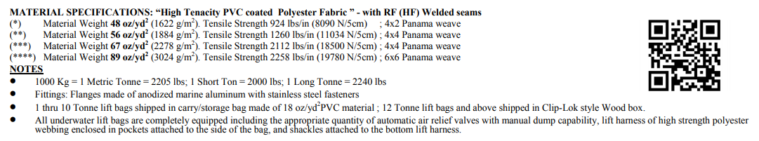
Figure2
. The fabric density , tensile strength and design specifications for all their bags they manufacture can be found at figure 2 .

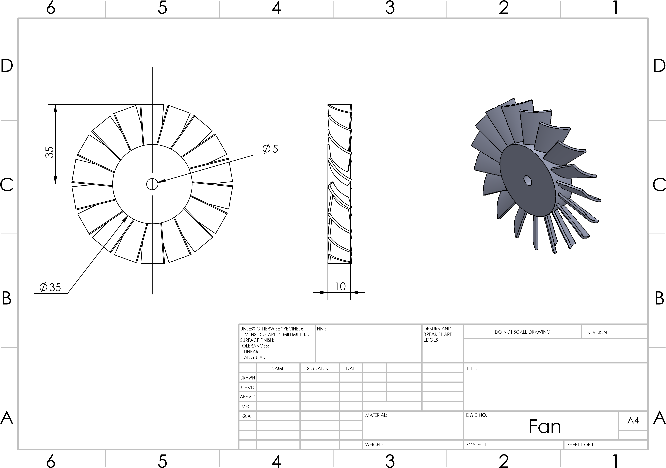
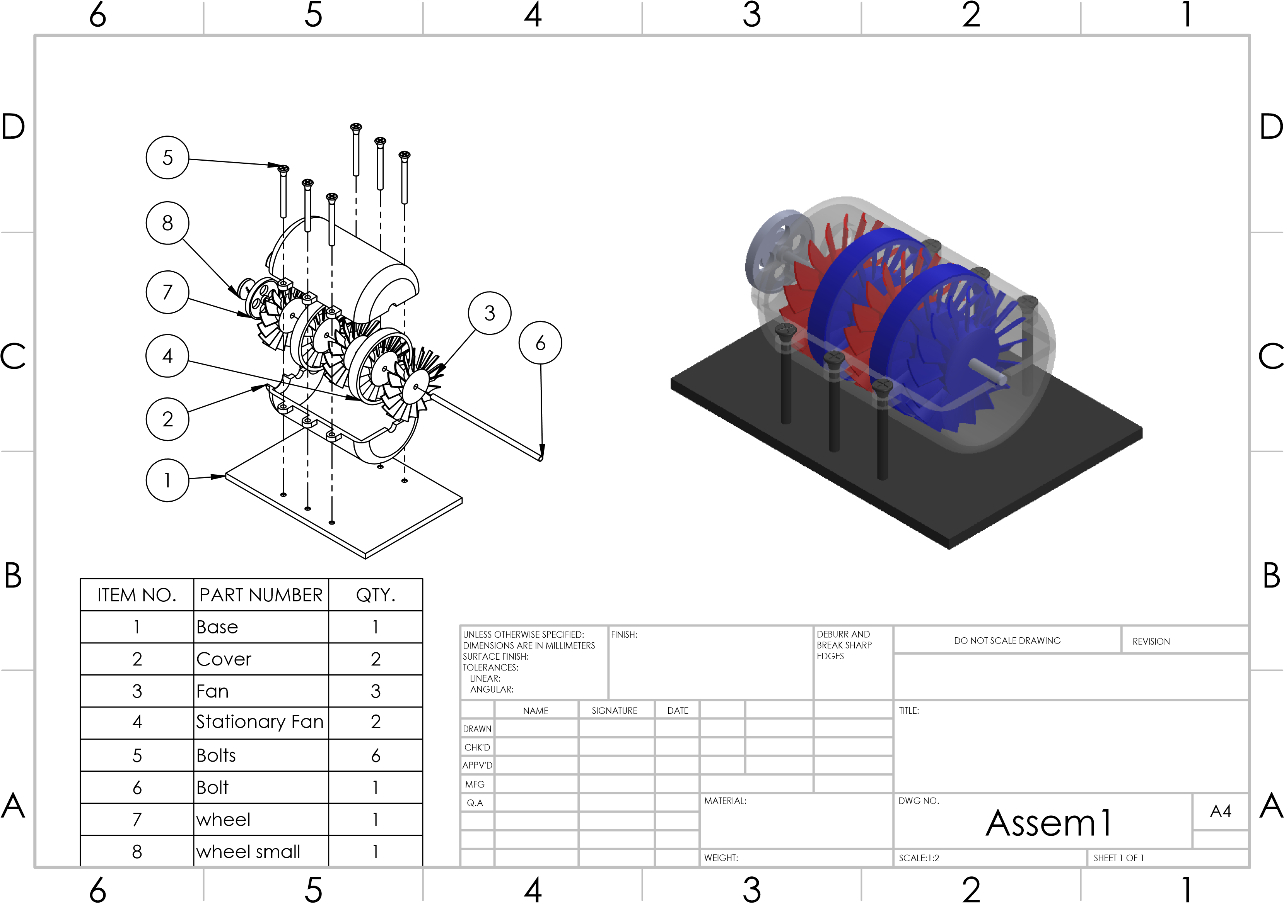
CAD Designs:
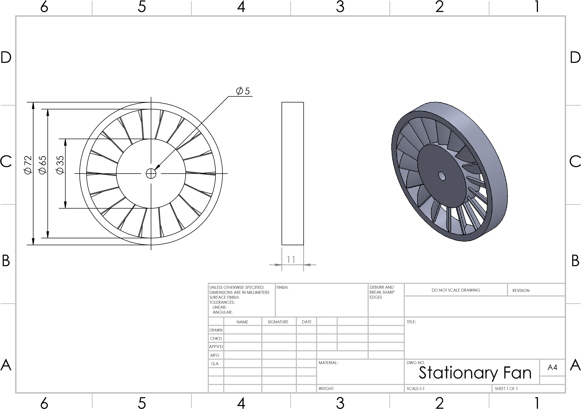

References
Seaflex, Project Overview: Vigdis Template Stabilisation, http://www.seaflex.co.uk/Information/Vigdis_Template.pdf. Last accessed 29/09/2010
IMCA D 016, Underwater air lift bags, 2007

Seaflex, Product Specification – 35t Air Lift Bag (ALB): Parts & Features, email communication from Graham Brading of Seaflex to Andrew Pimm on 01/10/2010

JW Automarine, Planning, Mobilisation and Implementation, http://www.jwautomarine.co.uk/download/lb_man4.pdf. Last accessed 30/09/2010

JW Automarine, Premier Parachute Totally Enclosed Liftbag, http://www.jwautomarine.co.uk/pr_lbs_pr_prte.htm. Last accessed 29/09/2010

Abele, A., Elkind, E., Intrator, J., & Washom, B. (2011). 2020 Strategic Analysis of Energy Storage in California: University of California, Berkeley School of Law; University of California, Los Angeles; and University of California, San Diego.

Adams, J. (1999). Ocean Currents Microsoft Encarta Encyclopedia [CD-ROM] (Vol. 2, pp. 191).

Arsie, I., Marano, V., Rizzo, G., & Moran, M. (2009). Integration of wind turbines with compressed air energy storage. Paper presented at the In AIP Conference Proceedings.

Bartholomew, C., Marsh, B., Hooper, R. (1992). US Navy Salvage Engineer's Handbook (Vol. 1):
Washington D.C. Naval Sea Systems Command.

Basler, B., & Zaugg, Z. (1985). Fuel flexibility in compressed air energy storage plants. Paper presented at the 30th International Gas Turbine Conference and Exhibit., Houston, TX, USA.

Bejan, A. (2006). Advanced engineering thermodynamics (3rd ed.): Wiley New York.
Boehme, T., Cammaert, G., McCurry, J., Judt, M., & Deckers, M. (2007). Windstore-largescale energy storage offshore. Paper presented at the Offshore Europe Conference, Aberdeen, UK.

Cheung, B., Cao, N., Carriveau, R., Ting, D. S. K. (2012). Distensible air accumulators as a means of adiabatic underwater compressed air energy storage. International Journal of Environmental Studies, 69(4), 566-577.

Coney, M. W., Stephenson, P., Malmgren, A., Linnemann, C., Morgan, R. E., Richards, R. A., ... & Abdallah, H. (2002). Development of a reciprocating compressor using water injection to achieve quasi-isothermal compression. Paper presented at the the 16th International

Compressor Engineering Conference, West Lafayette, IN.
Crotogino, F., Mohmeyer, K. U., & Scharf, R. (2001). Huntorf CAES: More than 20 years of successful operation. Paper presented at the Proceedings of SMRI Spring Meeting.

