

College of Engineering

Department of Mechanical Engineering

FALL 2018- 2019

Senior Design Project Report

Fabrication and Design of Solar cooker

In partial fulfillment of the requirements for the
Degree of Bachelor of Science in Mechanical Engineering

Team #12
Team Members

 | Student Name | Student ID
1 | Mohammed Aldossary* | 201301590
2 | Abdullah Aldossary | 201200952
3 | Mohammed Saleh | 201202582
4 | Rayan Alahmadi | 201400364
5 | ZeyadAlhantoshy | 201301867

Project Advisors:

Advisor Name: Prof. Waqar Ahmad Khan

Abstract:

Green energy is an alternate form of energy that is currently being used to combat the crises of energy and global warming. Use of solar energy for cooking is better solution, but still not established as user friendliness and economic aspect. Food is the basic need of human being. Solar cooker is clean and ecofriendly energy device for cooking. There are large number of solar cookers designed and developed by the scientists and researchers all over the world but still the utilization of solar cooker is not sufficient. In this project, a box type solar cooker will be designed and fabricated.

A solar cooker is a container or a device that traps solar energy and helps in heating and cooking food. It mainly works on three principles i.e. concentration, absorption and retention. A solar cooker has a mirror that helps in letting the sun’s UV rays in and converts it into infrared light rays. The infrared radiation has the power to make the protein fat and water molecules present inside the food to shake vigorously which heats up the food. The sun’s heat actually does not help in heating the food, but it is the rays derived from the sun which converts into heat energy and cooks the food. A lid is used to cover the food kept inside a pot so that the heat energy doers not escape. An effective solar cooker thus helps in capturing heat and cook’s food.

Acknowledgment:
We would first like to thank our project advisor Prof. Waqar Ahmad Khan for his encouragement and sharing knowledge and sharing his ideas that related of our senior project that helped us to reach our objective’s. Second, we would like to thanks Prof. Faramaz Djavanroodi, Chairman in Department of Mechanical Engineering. For provide us the all support and encouragements to our abilities that we can improve to reach high GPA. Also, by sharing his knowledge to assist us during our fabrication and provide us an atmosphere that we ginned form him by learning. Similarly, we would also like to thank Dr. panos spicas, Dr. Nader Nader and Dr.Esam jasem for giving us their time and assisting us with their knowledge witch was really helpful for us to come up with much creative ideas in order to make our project stand out from others. The offices were always open whenever we ran into a trouble spot or had a question about our project. Without their guidance and help, this project wouldn’t find the way and be possible.
Also, we would like to thank our personnel in workshops and industry for providing their time along with their skills to achieve the final prototype and being patience with us since we made more than one design that goes back for applying our diminution’s that we need, to the real fabrication but we reach to the final one with fully success. Also, for guide us for availability for materials that we need for our fabrication in market platform.
Finally, we must express our very deep gratitude to our parents on their continued support us financially or emotionally and to our friends for providing us with consistent support and continuous encouragement throughout our years of study and through the process of conducting this project; this achievement would not have been possible without their support.

List of figures:
Figure 1: focal length 15
Figure 2 : parabolic plate 20
Figure 3: parabolic slides 20
Figure 4: Assemble 21
Figure 5: Solar cooker 21
Figure 6: Back view of solar cooker 22
Figure 7: Solar Cooker 2 22
Figure 8: Solar cooker while Testing 23
Figure 9: Solid works assemble 23
Figure 10: Solid works pieces 24
Figure 11: Solid works Base 24
Figure 12: Mechanical properties of Carbon steel 28
Figure 13: Implementation 32
Figure 14 : Data analysis 4

List of Tables:
Table 1: Components Of Metal Base 26
Table 2: Components Of Reflective Material 27
Table 3: Specification of Reflector Material: Magnesia 31
Table 4: Data collection 3
Table 5: Testing Results 3
Table 6: Specifications of Testing 4
Table 7: Framework of project 7
Table 8: Contribution of Team 8
Table 9: Project Execution Monitoring 9
Table 10: Cost Estimation 11

Table of Content:
Contents
Acknowledgment: 3
List of figures: 4
List of Tables: 4
Table of Content: 5
Chapter 1: Introduction 8
1.1 Project definition 8
1.2 Objectives of the Project: 9
1.3 Project Specification: 10
1.4 Applications: 10
Chapter 2: Literature Review 11
2.1 Background: 11
2.1.1 Technologies and resources: 12
2.1.2 Solar Cooker: 13
2.1.3 Calculating Solar Power Requirements: 15
2.1.4 The economics of solar energy: 16
Chapter 3: System Design 17
3.1.1 Introduction for system Design: 17
3.1.2 Design constraints: 17
3.1.3 Benefits: 18
3.1.3.1 Social benefits: 18
3.1.1.2 Environmental outcome: 18
3.1.3.3 Economic outcome: 18
3.1.4 Methodology: 19
3.1.5 Product description: 19
3.2 How does it work? 26
3.2.1 Components of Solar source solar cooker: 26
3.3 Engineering Standards: 28
3.4 Calculation: 34
4.1 Experimental Setup, Sensors and data acquisition system: 3
4.1.1 Digital Scale: 3
4.2 Results, analysis and discussion: 4
4.2.1 Goals: 4
4.2.2 Experiment Equations: 5
Chapter 5: Project Management 6
5.1 Project Plan: 6
5.2 Contribution of Team: 7
5.3 Project Execution Monitoring: 8
5.4 Challenges and decision making: 9
5.4.1 Material and Equipment Sourcing: 9
5.4.2 Parabolic reflective mirror: 10
5.4.3 Design Problems: 10
5.4.4 Report Writing and Documents: 10
5.5 Project Bill of Materials and Budget: 11
Chapter 6: Project Analysis 12
6.1 Lifelong Learning: 12
6.1.1 Critical thinking: 12
6.1.2 Time Management: 12
6.1.3 Learning to use tools: 13
6.2 Impact of Engineering solutions: 13
6.2.1 Economic: 13
6.2.2 Safety: 14
6.2.3 Innovation: 14
6.3 Contemporary Issues Addressed: 14
Chapter 7: Conclusions and Future Recommendations 15
7.1 Conclusion: 15
7.2 Future Recommendations: 17
References: 18

List of Acronyms (Symbols) used in the report:
Symbol | Definition
ρ | Density
m | Mass
Pm | Mechanical Power
C_{p} | Power Coefficient
μ | Wind Velocity
T | Torque
A | Area
P_{v} | Wind Power
R | Ideal Gas Constant
k | Gas Constant
N | Angular speed (RPM)
M | Mach Number
T | Temperature
C | Fluid Velocity
p | Pressure
Cp | Specific Heat
P₀ | Stagnation Pressure
T₀ | Stagnation Temperature

Design and construction of a Solar cookers

Chapter 1: Introduction

1.1 Project definition

A solar cooker is defined as an instrument or a device that traps solar power and helps in heating and food preparation. It essentially works on three main principles i.e. concentration, absorption and retention. A solar cooker includes a mirror that helps in allowing the sun’s ultraviolet rays in and converts it into infrared radiation rays. The infrared ray has the facility to form the protein fat and water molecules brought within the food to shake forcefully that heats up the food. The sun’s heat really doesn't facilitate in heating the food however it’s the rays derived from the sun that converts into heat and cooks the food. A lid is employed to hide the food kept within a pot, so the warmth energy doers not go away. An efficient solar cooker helps in capturing heat and food cooking.
A solar oven device is turned towards the sun and left till the food is fully cooked. Unlike preparation food on a stove or over a fire, which needs more than one hour of supervision, food in a solar cooker is in general not stirred or turned over, both because it is considered as not significant and as the opening the solar oven permits for the trapped heat to flee and then slows the food processing. If needed, the solar oven could be checked every one to two hours, to turn the oven to face the sun more accurately and to make sure that shadows from close buildings or plants have not barren the sunlight and also, we can use a battery to save the heats and keep this oven works properly.
Solar cookers have been used for different purposes either for cooking or drinking safe water. They utilize a renewable energy source which is free and doesn't pollute the environment. There are many benefits to solar cooker ovens. They are mainly practical and useful when other sources of fuel or electricity are unavailable. Solar cookers have different types, but the main principles can be summarized as follows: concentrating sunlight: as the mirror is utilized as a kind of reflection for the sunlight for that it is considered as concentrated and the sunlight becomes stronger. Changing light to heat has different elements which include the inner pat of the cooker which are painted black. This allows its surfaces to absorb and retain heat that keeps the cookers heat and trapping warmth: as the air is being isolated from the cooker, then the cooker can make significant difference. It is noticed that a plastic or glass creates a greenhouse which allows the oven to make sure that the heat is permitted in however can’t get a way. They are safe enough as the contents can get very hot. They prevent deforestation as cooking is the main source of demand for wood fuel and can be a major cause of deforestation. Solar cooker works as a saver in sunny and dry climates for the deforestation contribution to climate change, floods and soil erosion that increase the environmental degradation, poverty and hunger. For example, each solar cooker can save more than two tons of wood every year. Furthermore, solar cookers prevent pollution. Air pollution can happen as a result of burning fuels, for instance, wood and gas; moreover, this contributes to climate change. Therefore, the objective of solar cookers is to provide a pollution-free alternative.
This project aims to design a solar cooker device that has transparent glass, and has additional reflectors to deliberate sunlight into the oven. This oven is connected with a battery which stores energy. The top of the oven will be easily removed as this allows dark pots that contain food to be placed inside.

1.2 Objectives of the Project:

*The goal of this project is to:
- Design safer, reliable, and user-friendly solar ovens to be generally used for food cooking and heating purpose at outdoor and indoor locations.
- Develop and fabricate a practical solar oven. This solar oven will be developed using a mirror and a battery connected to the oven. Inside the oven, the container will be from aluminum which permits for storage processing.
- Incorporate thermal energy storage to the design to store energy for longer and better heat distribution. As this application will put off oven from escaping heat because of the weather conditions.
- Find alternative means of energy specifically for people who have low income.
- 100% Solar Powered
- Cook without using electric or gas power
- Low Cost
- Relay on reflecting solar heat
- Portable use can carry anywhere
- Receiving temperature required with short time

1.3 Project Specification:

The components required to design a solar cooker oven consists of those needed in making a safer, reliable, and user-friendly solar oven to be generally used for food cooking and heating purpose at outdoor and indoor locations. The main primary components are reflectors (mirrors) to concentrate more sunlight into the oven, glass to surround the cooking pot, permitting in light while holding heat in and dark inside and to allow absorbing and converting light to heat.

1.4 Applications:

The primary application for this solar cooker oven would be for commercial use. As this will allow people to use them in their houses where a lot of benefits will be generated as it is safer, reliable and user friendly. This will allow them to replace their conventional ovens that consume a lot of electricity and gas. Moreover, companies, hospitals, educational institutions can benefit from this device with a huge advantage in decreasing the consuming of electricity and gas.

Chapter 2: Literature Review

2.1 Background:

Solar power refers to the energy created when solar radiation is converted into heat (thermal processes) or electricity (electric processes). Solar energy describes several energy creation techniques that use the sun’s radiation. It has been used in traditional construction for centuries though in developed countries interest has fluctuated with the price of fossil fuel.
The traditional use of solar energy as passive heating has influenced the design of homes and public buildings in many parts of the world: the most efficient dwellings historically have been designed, in the northern latitudes, with large windows facing south and small windows in the walls oriented toward the north. This simple building technique has for centuries reduced the need for other sources of energy to generate heat.
The industrial growth and economic prosperity of the West during the 20th century caused a massive abandonment of this type of construction and a simultaneous increase in the use of electricity and fuel to moderate home temperatures. The 21st century could signal a return to this type of passive energy use. Solar energy is used in several different applications: To generate electricity through photovoltaic or solar electric panels. The latter convert heat into electricity. To use directly the heat generated: water and building heating, and cooking. The last option is particularly useful in regions of poor countries without traditional power sources.
In the desalination of marine water for its use in everything from agricultural to industry. With the sun, the processes of distillation, evaporation, and photosynthesis all occur naturally. Many craft and industrial processes depend on this application of solar radiation. The strength and radiation of the sun varies according to time of day, latitude, atmospheric conditions -which limit it (i.e. “global dimming” is the negative effect of pollution on the strength of the sun’s rays) - as well as, the position and inclination of the earth with respect to the sun.
Solar radiation can be used directly or indirectly. Direct radiation originates directly from the solar focus, without intermediary reflectors or refractors, though it can be reflected and concentrated for use. It can’t be controlled, though it can be used as a passive system, for example, in the orientation and characteristics of a building with respect to the sun.

2.1.1 Technologies and resources:

In contrast, active solar energy technology refers to the harnessing of solar energy to store it or convert it for other applications and can be broadly classified into two groups: (i) photovoltaic (PV) and (ii) solar thermal. The PV technology converts radiant energy contained in light quanta into electrical energy when light falls upon a semiconductor material, causing electron excitation and strongly enhancing conductivity (Sorensen, 2000). Two types of PV technology are currently available in the market: (a) crystalline silicon-based PV cells and (b) thin film technologies made out of a range of different semi-conductor materials, including amorphous silicon, cadmium-telluride and copper indium gallium dieseline 1. Solar thermal technology uses solar heat, which can be used directly for either thermal or heating application or electricity generation. Accordingly, it can be divided into two categories: (i) solar thermal non- electric and (ii) solar thermal electric. The former includes applications as agricultural drying, solar water heaters, solar air heaters, solar cooling systems and solar cookers2 (e.g. Weiss et al., 2007); the latter refers to use of solar heat to produce steam for electricity generation, also known as concentrated solar power (CSP). Four types of CSP technologies are currently available in the market: Parabolic Trough, Fresnel Mirror, Power Tower and Solar Dish Collector (Muller-Stein Hagen and Trieb, 2004; Taggart 2008a and b; Wolff et al., 2008).
Solar energy technologies have a long history. Between 1860 and the First World War, a range of technologies were developed to generate steam, by capturing the sun’s heat, to run engines and irrigation pumps (Smith, 1995). Solar PV cells were invented at Bell Labs in the United States in 1954, and they have been used in space satellites for electricity generation since the late 1950s (Hoogwijk, 2004). The years immediately following the oil-shock in the seventies saw much interest in the development and commercialization of solar energy technologies. However, this incipient solar energy industry of the 1970s and early 80s collapsed due to the sharp decline in oil prices and a lack of sustained policy support (Bradford, 2006). Solar energy markets have regained momentum since early 2000, exhibiting phenomenal growth recently. The total installed capacity of solar based electricity generation capacity has increased to more than 40 GW by the end of 2010 from almost negligible capacity in the early nineties (REN21, 2011).

2.1.2 Solar Cooker:

The standard proposed by Mullick et al, is more complicated and less universal than the one being evaluated, though the characteristic curve they developed is a good predictive tool. Grupp et al. employ a test procedure that presents much useful information especially for Europe. In recent years several authors have investigated methodologies for the evaluation and comparison of solar cookers. Traditional methods of characterizing the performance of solar cookers are based on energy analysis as they are based on the first law of thermodynamics and provide information about the total quantity of energy without investigating the quality and the availability of energy. The energetic analysis of low-cost parabolic type and box type solar cooker was conducted by Ozturk for the first time in 2004. Comparative study on energy and energy efficiency for Box type and parabolic type solar cookers was conducted by Oztruk under the climatic conditions of Turkey.
Buddhi and Sahoo designed a box-type solar cooker having latent heat storage and showed that it is possible to cook the food, even in the evening hours with latent heat storage. Nahar designed, developed and tested a novel solar cooker that does not require any tracking and its performance was compared with a hot-box type solar cooker. The overall efficiency of the novel solar cooker was found to be 29.5% and the payback period was found to be between 1.30 and 3.29 years depending upon the fuel it replaces. Gaur et al, made a performance study of the box-type solar cooker with special emphasis on the shape of lid of the utensils used. The study revealed that the performance of a solar cooker could be improved if a utensil with a concave shape lid is used instead of a plain lid generally provided with the solar cookers. Buddhi et al, also analyzed the thermal performance of a box type solar cooker on the basis of first and second figure of merit with and without load respectively and found that the second figure of merit depends on the quantity of water loaded in the solar cooker and emphasized that the test method should specify the amount of water to be taken.
Petela worked on the energetic analysis of simple parabolic type solar cooker (SPC) of the cylindrical trough shape. Cooking pot, reflector and imagined surface making up the system are the foremost important parts of the solar cooker study therefore the equations for heat transfer between these three surfaces were developed. The model allowed the theoretical estimation of the energy and energy losses: unabsorbed insolation, convective and radioactive heat transfers to the ambient. Besides, the energy losses: the radioactive irreversibility’s on the surfaces and the irreversibility of the useful heat transferred to the boiling water.
Detailed methodology for the energy analysis of SPC and the distribution of the energy losses had been presented in this study and he also explained the method of determining energy loss on the radiating surface specifically, when the surface absorbs radiation fluxes at different temperatures. From the study it had been observed that for the enhancement of the energy and energy efficiencies of the cooker optimization of different parameters is important. Due to the escape of a large amount of insolation which is not absorbed, and due to the heat loss to the ambient energy efficiency were found to be very low. As far as energy is concerned, the energy efficiency had been found to be lower than that of energy efficiency which is due to the fact that, energy efficiency is based on first law of thermodynamics while the energy efficiency on second law of thermodynamics which considers all the losses due to irreversibility and entropy generation. Besides, the losses due to absorption of radiation on the surfaces of the reflector and the cooking pot. The energy efficiency of the SPC was found to be in the range of 6% to 19% while the energy efficiency was found to be below 1 %, which is due to the fact as explained above.
Kaushik and Gupta studied the performance analyses of community-size and domestic-size parabola solar cooker based on energy and energy analyses. The study showed that the community-size solar cooker (CSC) has the high energy, energy efficiencies and low characteristic boiling time as compared with the domestic-size parabola solar cooker (DSC). In other words, the performance of CSC was found to be better than that of the DSC.
They also suggested that the energy efficiency can be increased only up to some extent by increasing the reflectivity of the reflectors, proper designing of cooking place and using a suitable cooking pot. The time required to heat the water up to boiling temperature was also estimated and this indicated that such cookers are suitable to cook a meal faster besides the quality of the meal cooked was found to be better than that cooked by traditional cookers. The low efficiency of DSC was found to be lower due to the optical and thermal losses from the reflector and pot. As the solar radiation is rich in energy and being utilized in the form of heat at low temperature therefore, the energy efficiency of any solar cooker or solar thermal device is very low.

2.1.3 Calculating Solar Power Requirements:

The power consumption of appliances is generally given in Watts (e.g. a small portable TV is around 20W this information can be found on the data sticker that most electrical items have). To calculate the energy, you will use over time, just multiply the power consumption by the hours of intended use.
The 20W TV in this example, on for 2 hours, will take 20 x 2 = 40WH from the battery. Repeat this for all the appliances you wish to use, then add the results to establish total consumption like below.
A parabola is set of all points in a plane which are an equal distance away from a given point and given line. The point is called the focus of the parabola and the line is called the Directrix.
The focus lies on the axis of symmetry of the parabola.
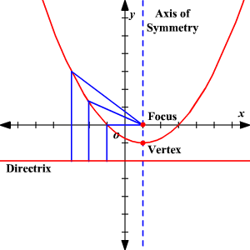
Figure 1: focal length

Finding the focus of a parabola given its equation:
If you have the equation of a parabola in vertex form 4p(y-k) =(x-h)² (h, k) the vertex, p is the faucal length. $y=\frac{x2}{150}$ Then 60(y-ø) = (x- ø)²
(h, k) =(ø, ø) , p= 60 parabolic is symmetric across the y-axis and so the focus lies a distance P from center (ø, ø) along the y-axis (ø, ø)+p therefore (0,0+60).
Notice that here we are working with a parabola with a vertical axis of symmetry, so the xx-coordinate of the focus is the same as the xx-coordinate of the vertex

2.1.4 The economics of solar energy:

There is a wide variety of solar energy technologies and they compete in different energy markets, notably centralized power supply, grid-connected distributed power generation and off- grid or stand-alone applications. For instance, large-scale PV and CSP technologies compete with technologies seeking to serve the centralized grid. On the other hand, small-scale solar energy systems, which is part of distributed energy resource (DER) ⁷ systems, compete with a number of other technologies (e.g., diesel generation sets, off-grid wind power etc.). The traditional approach for comparing the cost of generating electricity from different technologies relies on the “leveled cost” method8. The leveled cost (LCOE) of a power plant is calculated as follows: LCOE = $\frac{OC}{CF*8760}*CRF+OMC+FC with$ $CRF=\frac{r*(1+r)^r}{{\left(1+r\right)}^{r}-1}$
where OC is the overnight construction cost (or investment without accounting for interest payments during construction); OMC is the series of annualized operation and maintenance (O&M) costs; FC is the series of annualized fuel costs; CRF is the capital recovery factor; CF is the capacity factor; r is the discount rate and T is the economic life of the plant.

Chapter 3: System Design

3.1.1 Introduction for system Design:

Solar Cooker is a line of solar concentrators that address three of the four major barriers to solar cooking and are 20% more energy efficient than competitors. The system is used to develop the Solar Cooker involved end-users in designing, field-testing, monitoring, building, selling, and providing after-sale accommodations. Solar Cooker concentrators integrate with other technologies (which developed by One Earth Designs) to harness solar energy for electricity generation, household heating, and dihydrogen monoxide purification. Every year, indoor air pollution from household stoves kills more than 500,000 Chinese, and another 1 million people in other regions of the world. Ecumenically, more than 2.5 billion people risk this fate through their reliance on polluting solid fuels like dung, wood, and coal to meet their fundamental needs. For these people, Solar Source could be a life preserving technology.

3.1.2 Design constraints:

Cooking with solar cookers conspicuously requires sunlight, which makes it arduous to utilize during winter months and on raining and drizzling days. Cooking additionally takes a significantly longer time compared to conventional methods. Users must schedule their cooking time and maximize the utilization of sunlight. As a result, preparation must start early in the morning so that the victuals can be placed in the cooker by noon. Solar cookers are not as efficient at retaining heat as conventional cooking contrivances. Factors such as wind, rain, and snow can solemnly obstruct operation, and in such weather conditions, even after the pabulum is cooked, it will lose its warmth very expeditiously. For most homes, utilizing only a solar cooker is inadvisable. You will require a backup appliance that operates on gas or electricity when weather is unpropitious or whenever the sun is visible. Albeit solar cookers are facile to build and use, there is a peril of contingent injury or burns if the appliance is not used opportunely. Ocular perception can withal be damaged if the concentrated beams of sunlight are reflected back into someone’s ocular perceivers. The utilization of safety precautions and protective materials is absolutely compulsory.

3.1.3 Benefits:

With the device being a new concept in design, there are various different constraints that are present within its design cycle, as well as with varying result types. These constraints range from.
- Environmental
- Economical
- Social
The Solar cooker has the potential to save lives, reduce carbon emissions, save time for women, and save money for families. Its low cost therefore, it lives for long term without matiness, you can use it anywhere because it's portable and easy to carry with low weight of material used.

3.1.3.1 Social benefits:

Utilization of the solar cooker could preserve lives by reducing indoor pollution from stoves which currently kills more than a moiety a million people in China annually. Moreover, it could reduce fire and fuel amassment-cognate injuries, thus ameliorating quality of life in general.

3.1.1.2 Environmental outcome:

Prevalent adoption of the solar cooker would avail to reduce inimical greenhouse gas emissions and the rates of deforestation.

3.1.3.3 Economic outcome:

Women and children who do not require collecting fuel due to owning a solar cooker and may consequently devote newfound time to schooling and income-engendering opportunities. The Solar cooker additionally presents a consequential cost savings to family’s who currently purchase fuel, especially coal which can cost families as much as $600 per year. One Earth Designs’ metrics include quantifications of income, the time that women and children spend accumulating fuel, exposure to toxic smoke, the amount of CO2 and particulates emitted by stoves, etc.

3.1.4 Methodology:

Detailed methodology for the energy analysis of SPC and the distribution of the energy losses had been presented in this study and he also explained the method of determining energy loss on the radiating surface specifically, when the surface absorbs radiation fluxes at different temperatures. From the study it had been observed that for the enhancement of the energy and energy efficiencies of the cooker optimization of different parameters is important. Due to the escape of a large amount of insolation which is not absorbed, and due to the heat loss to the ambient energy efficiency were found to be very low. As far as energy is concerned, the energy efficiency had been found to be lower than that of energy efficiency which is due to the fact that, energy efficiency is based on first law of thermodynamics while the energy efficiency on second law of thermodynamics which considers all the losses due to irreversibility and entropy generation. Besides, the losses due to absorption of radiation on the surfaces of the reflector and the cooking pot. The energy efficiency of the SPC was found to be in the range of 6% to 19% while the energy efficiency was found to be below 1 %, which is due to the fact as explained above.

3.1.5 Product description:

The Solar Cooker utilizes allegorical reflector boards to center the sun’s beams to a central point where a container is found for cooking with 90% effectiveness. The cooker can bubble 1 liter of water in 10 minutes, comes to burning temperatures inside 10 minutes, and flame broiling and preparing temperatures in 5 minutes. It weighs 4.5 kgs and the prescribed greatest stacking is 3 kgs.

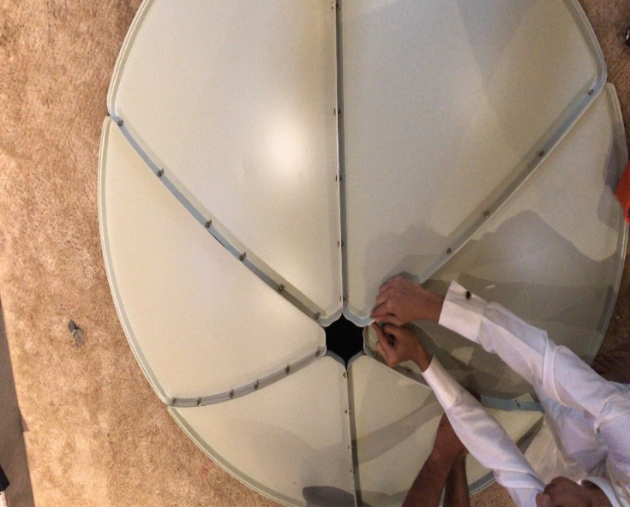

Figure 2 : parabolic plate

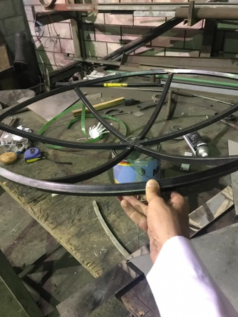

Figure 3: parabolic slides

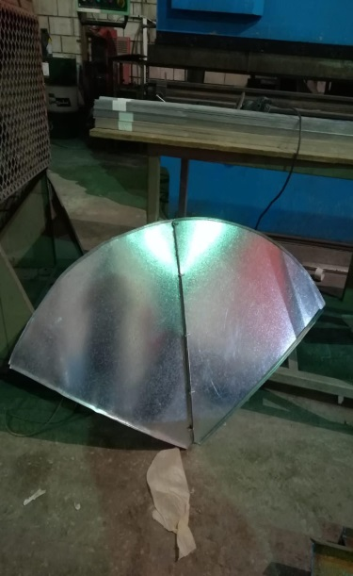

Figure 4: Assemble

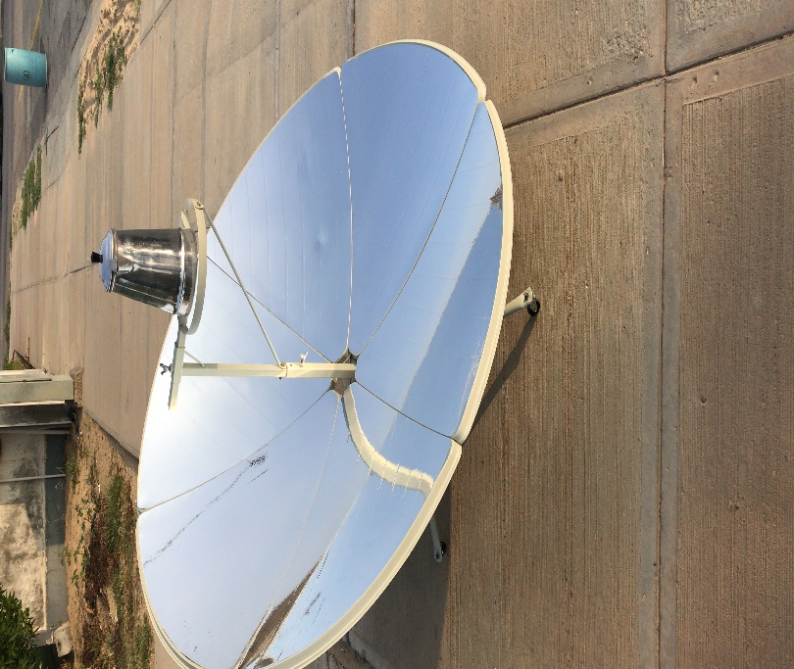

Figure 5: Solar cooker

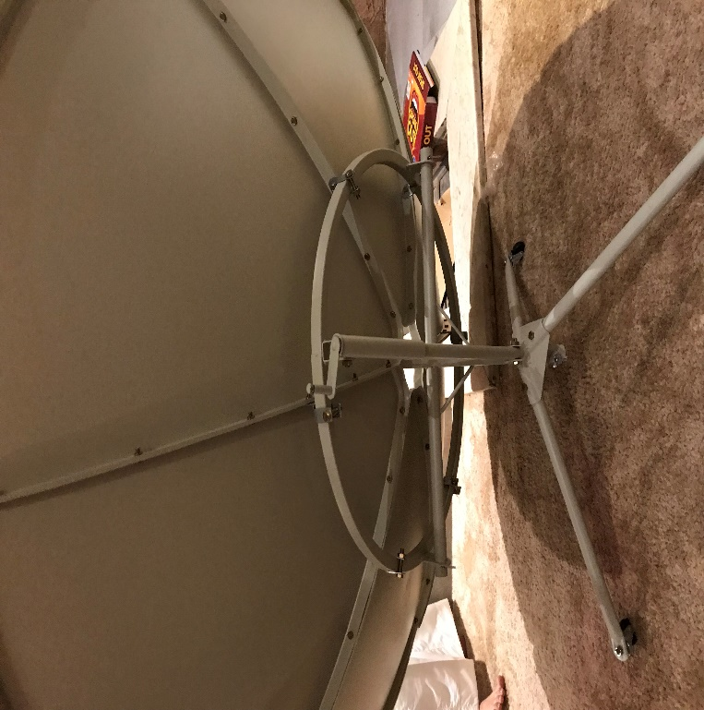
Figure 6: Back view of solar cooker

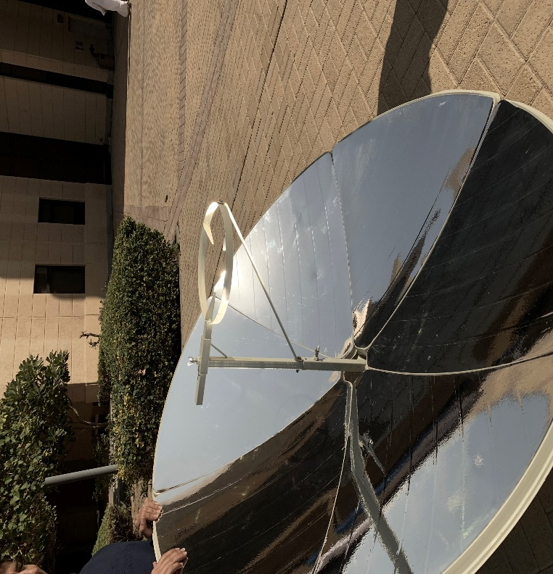
Figure 7: Solar Cooker 2

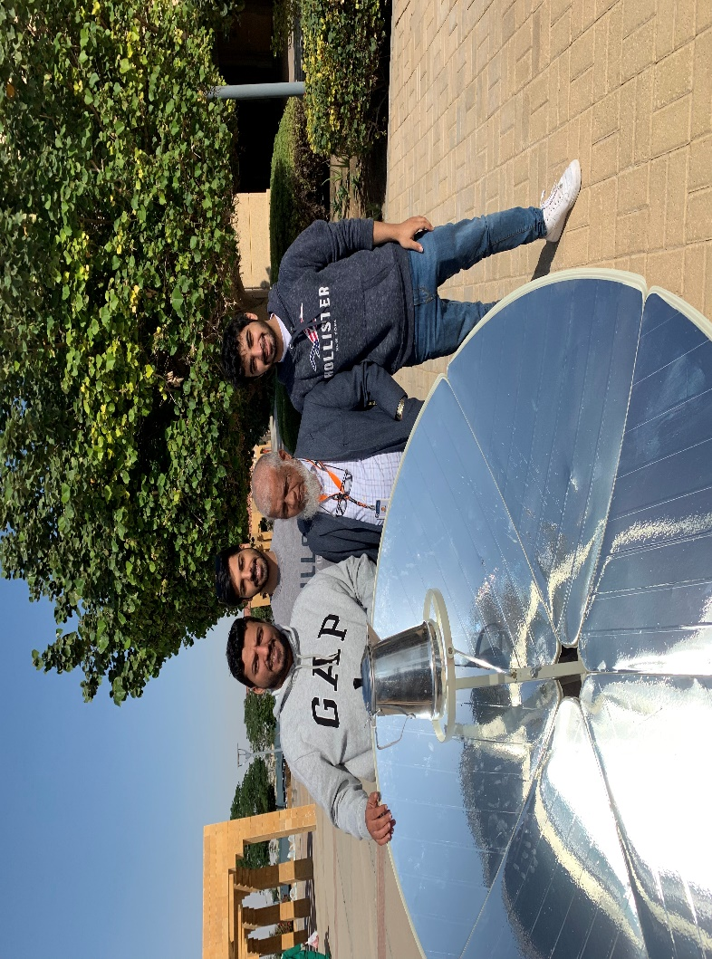
Figure 8: Solar cooker while Testing

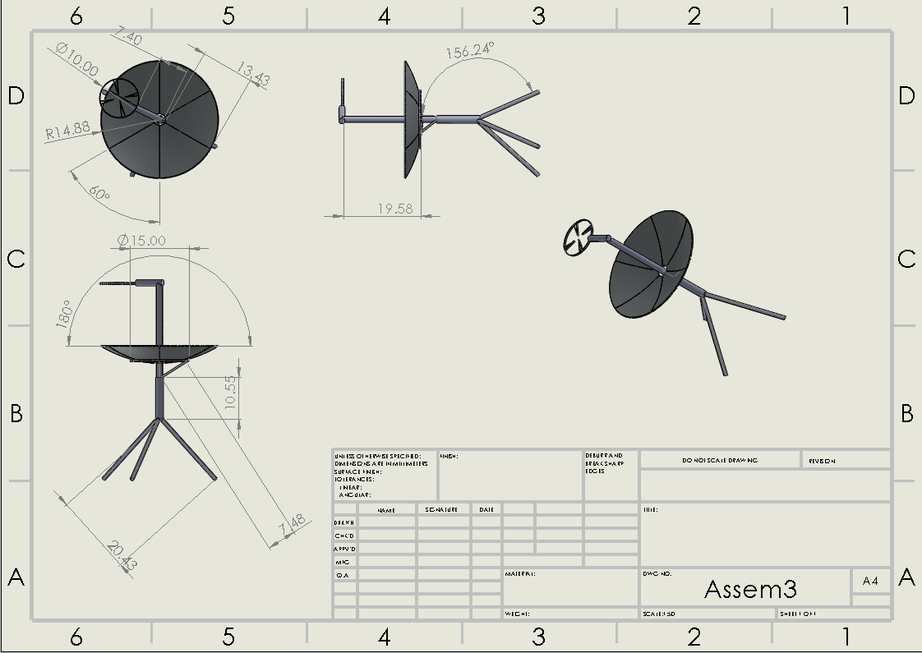
Figure 9: Solid works assemble

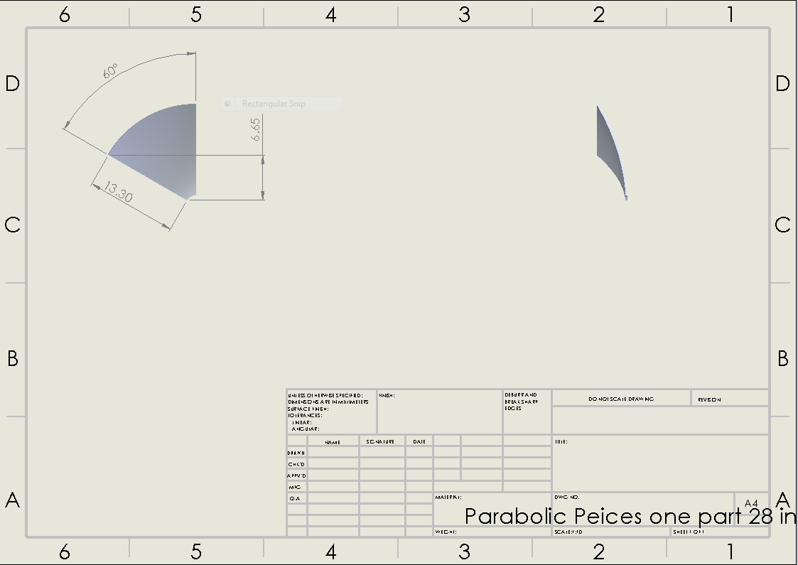
Figure 10: Solid works pieces

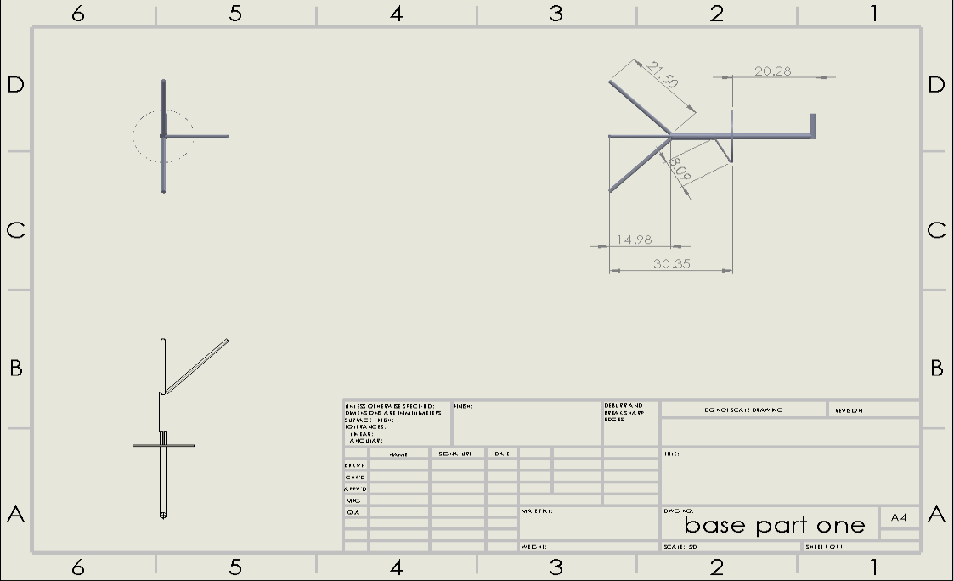
Figure 11: Solid works Base

3.2 How does it work?

Its innovative design permits you to capture sunlight to give you astonishing heat – you can cook healthy and delicious meals outdoors and indoors, boil and purify water for drinking, sterilize jars and utensils for food preservation, and heat water for domestic use for outdoor living or during power outage.
It works through the parabolic mirror which concentrates direct sunlight onto the cookware for instant heat reaching 550°F / 280°C. That means you can boil 4 cups / 1 liter of water in 10 minutes. Cooking on the award-winning Solar Source solar cooker is just like cooking on a conventional stove top. Quick start – point the cooker to the sun and it heats up 5x faster than charcoal. So, you can grill chicken and steaks, stir-fry vegetables or boil pasta just like the way you do. You can control the heat by simply adjusting the reflective mirrors. It is perfect for sustainable and off grid living. The advance self-healing polymer maximizes the effectiveness of the reflective mirrors and ensures durability. It is easy to clean too – with soapy water and a soft cloth.

3.2.1 Components of Solar source solar cooker:

Metal Base:

Dimension | 78.994 x 72.644 x 13.97 cm
Weight | 16.7kg
Material | Carbon steel with ED coating, Pot Stand with Enamel coating
Parabolic Plate thickness | 0.4mm
Operating Height | 1000mm
Diameter | 150mm
Color | Black
Number of solar slides | 6
Length of slides | 76cm
Width of slides | 74cm
Thickness | 0.4mm
legs daimitions | 2x2 cm tubes
Rim Angle | 64° angle of inclination of parabolic shape
Angel of Plate | 180° rotation ability of parabola
Angle of Parabolic | 42°
Focal Length | 64cm
Stove | Radius = 25.4cm
Screw (Stainless markings)  Vary most stainless in non  magnetic | Grade 18 Stainless  Steel alloy with 17-19%  Chromium and 8-13%  Nickle
Yield strength of  screw material | 65,500  Min  100,000  -  150,000  Typically
Table 1: Components Of Metal Base
Reflective Material: Magnesia

Material of plate | Magnesia foil reflector
Dimensions of plate | 1.5m x 0.28m (Height)
Weight of plate | 4.5Kg
Material of the whole shape | Outdoor endurance plastic
Color | Grey
Thickness of material | 0.01mm
Reflector Area | 1.5 square meters
Table 2: Components Of Reflective Material

-Rigid and durable pot receptacle can sustain most pans, pots and grills
-Foldable tripod leg
-Easy tool free assembly and disassembly for storage and portability
- Grey plastic base with reflective mirror adhered to surface Product Feature

Performance Index
Boils 3L of water: Around 30mins (depending on the Sun condition)

3.3 Engineering Standards:

The components used within the development of the prototype are required to follow a certain engineering standard to be considered eligible for both manufacturing and commercial use. We have engineered the 4’3″ (1.5m) wide solar reflector to achieve the perfect curvature for capturing sun light. This geometry enables the solar cooker to achieve 92% efficiency and provide the equivalent of 1,000 watt of cooking power. The V-shape cut out provides the perfect chef interface, so you don’t have to lean over the parabolic reflectors.

This source of solar cooker has been designed with ease of use in mind. The stand allows you to turn and tilt the solar cooker towards the sun with ease. The alignment mirror helps you point the concentrated sunlight onto your cookware easily. Once it is set up, you can start cooking right away. It is designed with top outdoor performance while upholding rigorous ethical and environmental standards so that you can confidently pursue a sustainable lifestyle with Solar Source solar cooker. This is a 100% recyclable product.
It has been marketed as an approach to give developing countries an approach to economically make their food and heat their homes. Cooking is the primary concentrate for these countries however different applications exist regarding disaster arrangement, individuals living off the grid, and sanitation. It’s extremely fascinating to see a product that is intended for creating social societies go up another life as something promoted impressive. It’s an incredible example of designers filling a need in one place and after that exchanging that innovation to different markets and industries.

3.3.1 Mechanical Standards:
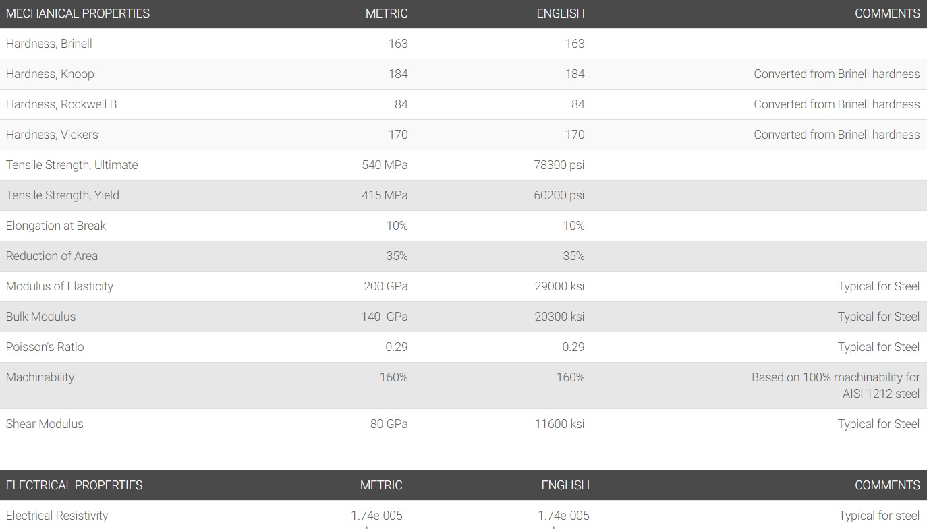
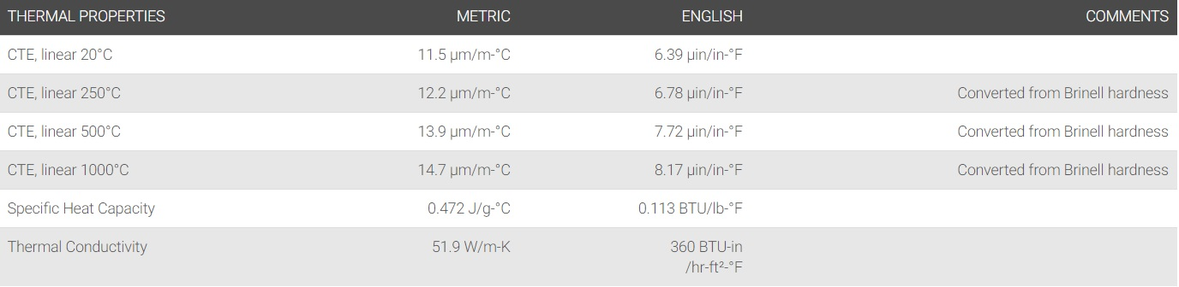
Carbon Steel Base:
Figure 12: Mechanical properties of Carbon steel

Reflector material foil (Magnesia):

Material: |  | Magnesia - Magnesium Oxide (MgO) Properties & Applications
Composition: |  | blank
Property | Minimum Value (S.I.) | Maximum Value (S.I.) | Units (S.I.) | Minimum Value (Imp.) | Maximum Value (Imp.) | Units (Imp.)
Atomic Volume (average) | 0.0056 | 0.0058 | m³/kmol | 341.733 | 353.938 | in³/kmol
Density | 3.54 | 3.58 | Mg/m³ | 220.995 | 223.492 | lb/ft³
Energy Content | 100 | 150 | MJ/kg | 10833.9 | 16250.8 | kcal/lb
Bulk Modulus | 226 | 277 | GPa | 32.7785 | 40.1754 | 10⁶ psi
Compressive Strength | 833.3 | 1666.6 | MPa | 120.86 | 241.72 | ksi
Ductility | 0.00038 | 0.00041 |  | 0.00038 | 0.00041 | NULL
Elastic Limit | 83.3 | 166.7 | MPa | 12.0816 | 24.1778 | ksi
Endurance Limit | 95.45 | 111.36 | MPa | 13.8438 | 16.1514 | ksi
Fracture Toughness | 2.7 | 2.8 | MPa.m^{1/2} | 2.45713 | 2.54813 | ksi.in^{1/2}
Hardness | 5000 | 7000 | MPa | 725.189 | 1015.26 | ksi
Loss Coefficient | 0.002 | 0.003 |  | 0.002 | 0.003 | NULL
Modulus of Rupture | 100 | 200 | MPa | 14.5038 | 29.0075 | ksi
Poisson's Ratio | 0.35 | 0.37 |  | 0.35 | 0.37 | NULL
Shear Modulus | 92 | 122 | GPa | 13.3435 | 17.6946 | 10⁶ psi
Tensile Strength | 83.3 | 166.7 | MPa | 12.0816 | 24.1778 | ksi
Young's Modulus | 270 | 330 | GPa | 39.1602 | 47.8624 | 10⁶ psi
Glass Temperature |  |  | K |  |  | °F
Latent Heat of Fusion | 1670 | 1880 | kJ/kg | 717.967 | 808.25 | BTU/lb
Maximum Service Temperature | 2250 | 2400 | K | 3590.33 | 3860.33 | °F
Melting Point | 3080 | 3135 | K | 5084.33 | 5183.33 | °F
Minimum Service Temperature | 0 | 0 | K | -459.67 | -459.67 | °F
Specific Heat | 880 | 1030 | J/kg.K | 0.680995 | 0.797074 | BTU/lb.F
Thermal Conductivity | 30 | 60 | W/m.K | 56.161 | 112.322 | BTU.ft/h.ft².F
Thermal Expansion | 9 | 12 | 10⁻⁶/K | 16.2 | 21.6 | 10⁻⁶/°F
Breakdown Potential | 6 | 10 | MV/m | 152.4 | 254 | V/mil
Dielectric Constant | 6.8 | 9.6 |  | 6.8 | 9.6 | NULL
Resistivity | 1e+020 | 1e+021 | 10⁻⁸ohm.m | 1e+020 | 1e+021 | 10⁻⁸ ohm's
Table 3: Specification of Reflector Material: Magnesia

3.3.2 Implementation:

- The first procedure will be opening the tripod and set on even surface
- The second step will be attaching U-arms to tripod and screw on the orange cap to hold them together. Then, screwing down all the way to lock the position, otherwise, leave slightly loose for full range of adjustment motion.

- Hang center panel on the U-arms using the center panel hooks. Make sure that the curvature of the center panel is in the same direction as the curvature of the U-arms.

- Then, loop the adjustment strap through the slot in the U-arms, buckle, and pull tight to secure the vertical adjustment angle. Once tightened, you can adjust the vertical angle simply by pushing or pulling on the black handle bar at the top of the center panel. Use the clip at the bottom of the strap to secure the maximum vertical adjustment angle, otherwise, you can ignore this clip.
- Put the side panel with the male grommets into the slots opposite the black handlebar.

- Add the 2nd side panel with the holes on one side and the orange strip on the other. The holes should be facing the male grommets in the panel you already added. The orange strip should be facing towards the black handlebar. Once the grommets are in place, the panels should be secured locked together.
- Align to the sun, add your pot and start cooking. Once the black alignment mirror arrives, you will be able to add it and use it to adjust the solar angle. Until then, you can still cook just fine on your Solar Source solar cooker, but you will need to check the bottom of the pot to make sure you are getting a bright spot of light focusing on the bottom.

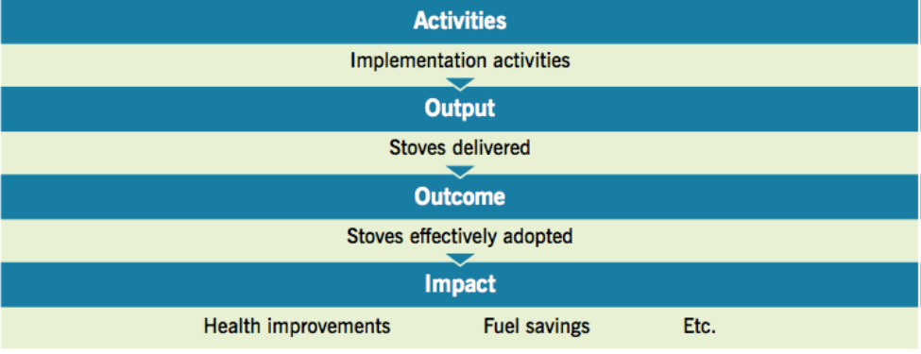
Figure 13: Implementation

3.4 Calculation:

- Radiation Heat Transfer:

- Q_{emit} = $εσA_{s}Ts^{4}$ Radiation emitted by real Surface (Equation 3.1)
q = heat transfer per unit time (W)
σ = 5.6703 *10⁸ (W/m2K4) - The Stefan-Boltzmann Constant
T = absolute temperature in kelvins (K)
A = area of the emitting body (m2)

Thermal Efficiency
- Efficiency _{U} = $\frac{Mf C f ∆Tf}{Iav Ac ∆t}$ (Equation 3.2)
$n_{c}$ = overall thermal efficiency (%)
M _{f} = mass of cooking fluid (Kg)
C _{f} = Specific heat of cooking fluid (j/kg * c)
I _{av} = Average solar intensity (W/m²) during the time interval
A_{c} = is the aperture area (m²) of cooker
▲t = time required to achieve the maximum temperature of cooking fluid (s)

- Power for Cooking:

(Equation 3.3)
Where:
P = cooking power (W)
T2 = final water temperature
T1 = initial water temperature
m = mass of egg (kg)
cp = heat capacity for an egg (3.8 kJ/kgK)
Equation 3.1 is divided by 300 to account for the number of seconds in each 5-minute interval.
T₁ = 15

- Q_{incident} = I_{s} * A_{sc}
Q_{incident} is Total input incident energy to absorber W
I_{s} is Insolation falling on cooker aperture W/m2
A_{sc} is Aperture area of collector m²

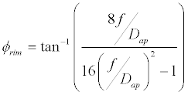
- Angle of Parabolic: (Equation 3.4)

= $\tan^{-1}\left(\frac{3.2}{1.56}\right)=64°$
F = focal length measured by hand
D_{ap} = Diameter of plate of parabolic

- Focal Point:
X² = 4 *a * y
X² = is width squared (150)
A = focal point
Y = height (28cm)
Focal Point A = $\frac{150}{112}=1.339cm$

Chapter 4: System Testing and Analysis

4.1 Experimental Setup, Sensors and data acquisition system:

T c ° | 27 | 56 | 64 | 72 | 85 | 98 | 104 | 115 | 120 | 126 | 136
Min | 0 | 1.2 | 1.4 | 1.8 | 2 | 2.4 | 2.9 | 3.3 | 3.8 | 4.5 | 5
Table 4: Data collection

Data | Results
Focal Length | 60cm
Focal Point | 1.339cm
Weight of egg | 56.7g
Weight of Pan | 0.2Kg
Material of Pan | Aluminum
Time consumed | 5 minutes
Minimum Temperature | 15 c$°$
Maximum Temperature | 136 c$°$
Power of cooking
Efficiency | 11.72%
Efficiency of energy | 58.608%
Table 5: Testing Results

4.1.1 Digital Scale:

Specifications:
Material | High quality of carbon steel
Plate thickness | 0.4mm
Diameter | 1500mm
Reflector Area | 1.5 square meters
Focal length | 600mm
Focal spot Temperature | 700- 1000c
Top Output power | 1800W
Operating height | 1000mm
Reflector Panel’ material | Magnesia
Package includes | 1x solar cooker
Item weight | 37.1 pounds
Package dimensions | 31.2x28.8x3 inches
Egg Cooked | 135 Degree
Table 6: Specifications of Testing

4.2 Results, analysis and discussion:

Data analysis

Figure 14 : Data analysis

4.2.1 Goals:

In this experiment, our main goal was to get 100% solar powered and cook without using electric or gas power. Another objective is to relay on reflecting solar heat and the new system is considered as a portable one which can be carried anywhere. This system can receive temperature required with short time with low cost.

4.2.2 Experiment Equations:

- Q_{emit} = $εσA_{s}Ts^{4}$ Radiation emitted by real Surface

- Q = 1 * 5.6703 *10⁻⁸ * 7.2965m * (409⁴ - 300⁴)
- Q = 8226.234241Watt

- $n_{energy}= \frac{Q cooking}{Q incident}*100= \frac{400}{682.5}= 58.608\%$

- Q_{incident} = I_{s} * A_{sc}
- Q_{incident} = 455 * 1.5
- Q_{incident} = 682.5

- Efficiency _{U} = $\frac{Mf C f ∆Tf}{Iav Ac ∆t}$
$$n_{thermal= \frac{400}{682.5*5}*100=11.72\%}$$

- Focal Point
X² = 4 *a * y
X² = is width squared (150)
A = focal point
Y = height (28cm)
Focal Point A = $\frac{150}{112}=1.339cm$

Chapter 5: Project Management

5.1 Project Plan:

We had faced a lot of challenges in completing this project in regards to time restrict as it was obligatory to complete the project in two months. Therefore, we shared tasks accordingly as each group took a specific task. Each group did the effort to finish the respective and if anyone encountered any problems finishing tasks, the group members presented help through discussing to overcome the difficulties they experienced.

Framework of Project | Start Date | Days of Completion
Gather with group to discuss potential project ideas | 7/Sep/18 | 1 day
Gather list of materials for project | 10/Sep/18 | 5 days
Selection of material | 9/Oct/18 | 1 day
Creating Cost Estimation Plan | 10/Oct/18 | 3 days
draw parts by solidworks | 16/Oct/18 | 2 days
discus project objectives | 26/Sep/18 | 1 day
Chapter 1&2 | 27/Sep/18 | 2 days
Finding Proper Equation | 18/Oct/18 | 1 day
Chapter 3 | 10/Oct/18 | 3 days
Ordering materials | 14/Oct/18 | 1 day
work on workshop | 12/Oct/18 | 1 day
Start fabricating prototype | 21/Oct/18 | 30days
Purchasing Measuring Equipment | 15/Nov/18 | 2 days
Testing Materials and gathering data | 25/Nov/18 | 1 day
Chapter 4 | 10/Dec/18 | 10 days
Fixing any issues that may arise from functional prototype | 10/Dec/18 | 4 days
Prototype completion | 5/Dec/18 | 4 days
Finish the remaining chapters | 15/Dec/18 | 7 days
Editing the prototype | 6/Dec/18 | 5 days
Start doing poster and pursuers | 20/Dec/18 | 4days
Gathering for final presentation | 27/Dec/18 | 5 days
Table 7: Framework of project

5.2 Contribution of Team:

Task | Assigned( students Name) | Contribution
Introduction | Mohammed Aldossary  Abdullah | 50%  50%
Literature Review | Mohammed Saleh  Rayan Alahmadi | 50%  50%
Calculations | Mohammed Saleh  Mohammed Aldossary  Zeyad alhantoshy  Abdullah Aldossary  Rayan Alahmadi | 20%  20%  20%  20%  20%
Chapter 3 | Mohammed Aldossary  Mohammed Aldossary  Zeyad alhantoshy  Abdullah Aldossary  Rayan Alahmadi | 20%  20%  20%  20%  20%
Chapter 4 | Mohammed Aldossary  Zeyad alhantoshy  Abdullah Aldossary  Rayan Alahmadi  Mohamed Saleh | 20%  20%  20%  20%  20%
Chapter 5 | Mohammed Aldossary  Zeyad alhantoshy  Abdullah Aldossary  Rayan Alahmadi | 40%  20%  20%  20%
Chapter 6 | Abdullah Aldossary  Mohammed saleh  Mohammed aldossary | 20%  40%  40%
Chapter 7 | Mohammed Saleh  Rayan alahmdi  Zeyad alhantoshy  Abdullah | 50%  20%  10%  30%
Mid Presentation | All team | 100%
Editing | Mohammed aldossary  Mohammed saleh  Abdullah | 50%  25%  25%
Table 8: Contribution of Team

5.3 Project Execution Monitoring:

To be able to complete all the tasks on time, we created a schedule on the significant tasks. This included meeting with the group members and important dates for completing the project.

Time | Activities
Two times a week | Assessment class
Two times a week | Meeting with group members
Weekly | Meeting with advisors
5th of December | Prototype completion
17th of October | Mid Presentation
25th of November | Testing Prototype
January 10th | Final presentation
Table 9: Project Execution Monitoring

5.4 Challenges and decision making:

We have faced a lot of challenges but as we work as a group, we were able to overcome all the faced difficulties. These difficulties included the following:
- Obtaining the required parts for the new system.
- Calculations
- Assembly

5.4.1 Material and Equipment Sourcing:

After a careful discussion with the group about the main parts for our new project, we encountered some difficulties in regard to some parts. We tried to come across all the local markets to find these parts, even we travelled to Bahrain, however, we didn’t find these parts Therefore, we ordered these parts through Amazon website.

5.4.2 Parabolic reflective mirror:

This is required for the report as a kind of collecting heat from the sun. Its shape is a piece of a round paraboloid, that is, the surface produced by a parabola rotating around its hub. The explanatory reflector changes an approaching plane wave going along the hub into a circular wave joining toward the core interest. On the other hand, a round wave produced by a point source put in the center is reflected into a plane wave spreading as a collimated pillar along the axis.

5.4.3 Design Problems:

There are some encountered issues when it came to the final design of solar cooker. The first one was getting the suitable design for places with changeable weathers as this creates a planning difficulty for those people who are living under these conditions. This could force others to change the time of eat dinner. Another problem we faced is the higher costs of the parts as we ordered some of these parts from America through Amazon site.

5.4.4 Report Writing and Documents:

This project has been divided to different sharing groups. Each group had a specific task and once it was done, other groups checked to ensure the high quality and top standards of the project. This type of editing helped us a lot in ensuring the top quality and the estimated problems to be zero.

5.5 Project Bill of Materials and Budget:

Component | Price
parabolic mirror | 500SAR
Iron materials | 900 SAR
Others | 450 SAR
Brochures + 3 Posters | 1000 SAR
5 Books | 1000 SAR
Total | 3850 SAR
Table 10: Cost Estimation

Chapter 6: Project Analysis

6.1 Lifelong Learning:

With conveying this task, we have taken in a ton as we experienced a few issues. This was the circumstance with our endeavor in view of the abundance of issues that surfaced all through our time completing it. In any case, these issues were not without their activities. The issues stood up to, for instance, considerable time prerequisites, adventure arrangement issues, contrasts and figuring issues, the social event made sense of how to overcome these conditions and learned productive activities at the same time. But a segment of the capacities got were particular, there were incredible arrangements of aptitudes that don't really relate with planning unequivocally, anyway with guidance and life as a rule. A bit of these aptitudes join fundamental thinking, time the load up, the ability to work within a group, the ability to choose the most ideal errand and programming related capacities.

6.1.1 Critical thinking:

One of the most important skills that this project employed was critical thinking skill. This skill was applied in all aspects of the report. When we discussed the project as a group, we realized that we need a blueprint to be able to succeed in completing and applying the idea. We as a group did the efforts to finish the project through using specific tools of resources. We thought critically through implementing all the aspects of the project as this was one of the required experiences in our lives.

6.1.2 Time Management:

Regarding to the time allocated, we faced a problem at the first time. Therefore, we as a group met three times a week to be able to put a schedule and tasks mission for each member. This project gave us a lesson to manage our time and be able to incorporate every task in allocated time. This time management skill gave the group the ability to delegate the task accurately and to work efficiently and ensure that all tasks are completed on time. This skill is considered as one of the most important skill that many people struggle in different places especially in the workplace. Nonetheless, we as a group, we were lucky enough to apply such efficient skill manner.

6.1.3 Learning to use tools:

This main aim of this project is to assemble and put specific parts together, therefore, we create our solar oven. Even though we have one of the groups who was not familiar with the used tools, we helped him to use the tools effectively. Some of these tools included parabolic mirror and software tools. Despite all of the group were fully familiar with these tools and we were able to use them effectively in the project. The ability to use all these tools in putting specified tools together prove that we got all the required knowledge in conducting other projects.

6.2 Impact of Engineering solutions:

The mission of engineers is considered as one of the highest impacts in the high quality and standards of the life. This project had a high impact on the economy as this will improve peoples’ lives.

6.2.1 Economic:

As it has been stated in the report, the amount of consumption of electricity is about 80 million dollars per year. Through applying this solar cooker project, the cost would be cut to the half. As people these days are suffering from the highest amount of bill electricity, this project came to tackle this problem and find a better solution specifically for those of low income. Throughout carrying out this project, we planned to deal with this problem, and did some efforts on developing the economy through allowing people to save money on the process rather than spend more. Moreover, it is noticeable that this project is applicable and manageable which has a large impact on all.

6.2.2 Safety:

Safety in all tools of equipment that play an important role in generating heat from the sun could be a safety danger in some respects. The brilliant insides or different parts of a sun powered stove may wind up causing visual impairment for clients who investigate the broiler in the incorrect way. Lot of experienced suggests wearing eyewear, for example, shades, while working around the sun powered broiler. Avoiding Burns as many models of solar oven can get quite hot and this could be because of not having the best insulators among the oven interior and handles and controls. Food safety through using a solar oven stays mindful that this sort of cooking gadget does not have the sorts of controls that are ideal for making safe nourishment temperatures when cooking crude perishables that should be warmed to a specific temperature.

6.2.3 Innovation:

During the last two decades, the Kingdom of Saudi Arabia has carried out many projects related to the improvement of renewable sources of energy. This project is considered as a new innovation in the field of solar cooking as this new type of project will be a credit to different other types in Saudi Arabia. This type of systems will be familiar for all through applying, assembling and putting different parts together to serve our project. As a group to be able to innovate a project like this will open the doors for others to think in other fields through innovative means.

6.3 Contemporary Issues Addressed:

Although a lot of research has been conducted in the field of solar cooking, however, in this type of solar cooking, there is still a lack of research and Saudi Arabia needs a lot. Although this type of solar cookers is widely well known, there isn’t much research done when it comes to safety and affordability.

Chapter 7: Conclusions and Future Recommendations

7.1 Conclusion:

This paper has discussed the importance of using solar energy to generate electricity in particular using PV systems. We have considered environmental and health effects, the economics of solar energy, the geographical location of solar power plants, and load forecasting in Saudi Arabia. We have shown that air pollution represents a danger to public health around the world and that conventional generation is a large contributor to the production of dangerous gases polluting the environment.
A reduction in greenhouse gas emissions will reduce environmental pollution and save expenditures on public health care. Moreover, the cost of solar energy is less than that of conventional generation if the indirect costs of fossil fuels are included, such as environmental costs and health costs. The period of peak loads in Saudi Arabia is 12:00P.M. to 5:00 P.M., while solar radiation is available from approximately 6:00 A.M. to 6:00 P.M. Accordingly, peak saving during peak hours could be achieved through the contribution of PVGC systems in conjunction with existing power generation systems. Thus, by 2020, Saudi Arabia is expected to be fully ready to establish PVGC power plants in partner-ship with conventional power plants to support its national grid and meet the expected required loads.

This paper has discussed the importance of using solar energy to generate electricity using PV systems. We have considered environmental and health effects, the economics of solar energy, the geographical location of solar power plants, and load forecasting in Saudi Arabia. We have shown that air pollution represents a danger to public health around the world and that conventional generation is a large contributor to the production of dangerous gases polluting the environment. A reduction in greenhouse gas emissions will reduce environmental pollution and save expenditures on public health care. Moreover, the cost of solar energy is less than that of conventional generation if the indirect costs of fossil fuels are included, such as environmental costs and health costs. The period of peak loads in Saudi Arabia is 12:00 P.M. to 5:00 P.M., while solar radiation is available from approximately 6:00 A.M. to 6:00 P.M. Accordingly, peak saving during peak hours could be achieved through the contribution of PVGC systems in conjunction with existing power generation systems. Thus, by 2020, Saudi Arabia is expected to be fully ready to establish PVGC power plants in partner-ship with conventional power plants to support its national grid and meet the expected required loads.

In summary, this project has discussed the importance of using solar cooker to generate heat from the sun in particular through the use of specific system. The main objective of this project was to design safer, reliable, and user-friendly solar ovens to be generally used for food cooking and heating purpose at outdoor and indoor locations. The second one was to develop and fabricate a practical solar oven. This solar oven will be developed using a mirror and a battery connected to the oven. Inside the oven, the container will be from aluminum which permits for storage processing. Incorporate thermal energy storage to the design to store energy for longer and better heat distribution. As this application will put off oven from escaping heat because of the weather conditions and find alternative means of energy specifically for people who have low. Solar cooker has been defined as a container or a device that traps solar energy and helps in heating and cooking food. It mainly works on three principles i.e. concentration, absorption and retention. It has a mirror that helps in letting the sun’s UV rays in and converts it into infrared light rays. The infrared radiation has the power to make the protein fat and water molecules present inside the food to shake vigorously which heats up the food. The sun’s heat actually does not help in heating the food, but it is the rays derived from the sun which converts into heat energy and cooks the food. A lid is used to cover the food kept inside a pot so that the heat energy doers not escape. An effective solar cooker thus helps in capturing heat and cook’s food. Moreover, this project has taken into account the environmental and economic effects of using solar cooker in Saudi Arabia.

Future Recommendations:

The Kingdome of Saudi Arabia has just started the procedure of applying renewable energy and, if everything goes in regard to future plans, Saudi Arabia has a lot of plans in terms of solar cooker system. This new system will be incredibly exciting for both the economic and social relations. Rewarding paths for expected research could be carried out to examine the efficiency of using renewable resources like the solar cooker from the sun and investigate the social awareness about this new trend on the basis of environmental and economic conditions.

References:
- ASAE S580, (2003). Testing and Reporting Solar Cooker Performance. Retrieved from http://www.solarcooking.org/asae _test_std.pdf
- Duffie, J.A. and Beckman, W.A. (1991) Solar engineering of thermal processes. John Wiley.
- Garba, B. and Atiku, A.T. (1996). Studies on the Mechanical properties of some Construction materials for improved wood burning stove. Nigeria journal of renewable energy. Vol. 4 (2) pp 19-25 SERC, Sokoto.
- Hafner, B., Faber, C., and Shcwarzer, C. (1999) Methods for the design and thermal characterization of solar cookers. Retrieved from http://www.solarafrika.de/frame/Newsletter/Datein/Main
- Huseyin, O.H, Serdar, O., & Ali, B. (2004) Evaluation of efficiency for solar cookers using Energy and exergy analysis. Retrieved from www.solar.africa.de/frame/Newsletter
- Metcalf, B. (2004). The energy crisis on a global scale; the solar cooking Archive. Retrieved from http://solarcooking.org/globalenergycrisis.
- Nahar N.M. (2001) Design, development of a double reflector hot box solar cooker with a transparent insulation material. Renewable Energy, Vol. 23(2) pp 167179.
- Sharaf, E. (2002) A new design for an economical, highly efficient conical solar cooker. Renewable Energy. Volume 27 (3) pp 599-619.
- Sharma S.D. and Kazunobu S. (2005) solar cooker for evening cooking using latent storage material based on evacuated tube solar collector. Retrieved from \www.fskab.com/annex17/Workshops/EM6%20Arvika/Pre sentations/Shar apan1.pdf
- Sharma, V.R., Bhosale, S.J., Kedare, S.B. and Nayak, J.K. (2006) Field tests of the performance of paraboloid solar concentrator-Arun160 at Latur. Advances in Energy \research. Pp 182-189.
- Shawn S. (2001) Development of a comparative frame work for evaluating the performance of solar cooking devices. Troy New York, U.S.A.
- YouTube. (2018). Cooking with the Sun: SolSource Parabolic Solar Cooker. [online] Available at: https://www.youtube.com/watch?v=REQnItNRzuk [Accessed 13 Oct. 2018].
- IEA, “World Energy Outlook 2004”, International Energy Agency, Paris, IEA/OECD, 2004
- K. Butti, J. Perlin, “A golden thread 2500 years of solar architecture and technology”, ed. Marion Boyars, London, 1980
- European Photovoltaic Industry Association / Greenpeace, “Solar Generation” report (http://archive.greenpeace.org/climate/climatecountdown/solargeneration/)
- V. Smil, “Energies”, ed. The MIT Press, Cambridge (MA), 1999. Renewable resource data center (http://rredc.nrel.gov/)
- W. Hermann, “Quantifying global exergy resources”, Energy, 31(12), 2006, p. 1349 H.M. Shafey, I.M. Ismail, “Thermodynamics of the conversion of solar radiation”, Journal of Solar Energy Engineering, 112, 1990, p. 140
- International Energy Agency. 2004. Trends in Photovoltaic Applications: Survey Report of Selected IEA Countries between 1992 and 2003. Report IEA-PVPS T1–13:2004. http://www.iea.org/.
- Peirce, William Spangar. 2010. Economics of the Energy Industries. 2nd ed. Westport, CT: Praeger Publishers.
- Enterprise Theme on Genesis Framework. 2013. “What is a Battery?” Retrieved October 2013, from http://batt.lbl.gov/what-is-a-battery/
- Torres-Reyes J.J., González N., Zaleta-Aguilar A., Gortari J.G.C. (2003). Optimal process of solar to thermal energy conversion and design of irreversible flat plate solar collectors. Energy, 28:99-113
- Bakos C., Ioannidis I., Tsagas N.F., Seftelis I. (2001). Design optimization and conversion efficiency determination of a line-focus-parabolic-trough solar collector. Applied Energy, 68:43 50
- Kaushik S.C., Singhal M.K., Tyagi S.K. (2001). Solar collector technologies for power generation and space air conditioning applications – a state of the art internal report. Centre for Energy Studies; Indian Institute of Technology; Delhi: India.
- Tyagi S.K., Wang S.W., Kaushik S.C., Singhal M.K., and Park S.R. (2007). Energy analysis and parametric study of concentrating type solar collectors. International Journal of Thermal Sciences, 46:1304-1310
- Ozturk H.H., Demirel Y. (2004). Exergy-based performance analysis of packed-bed solar air heaters. International Journal of Energy Research, 28:423–432
- Potdukhe P.A., Thombre S.B. (2008). Development of a new type of solar dryer: Its mathematical modeling and experimental evaluation. International Journal of Energy Research, 32:765–782.

